Module Four:
The Chair’s Role in Supporting Strategic Leadership

Key themes
This module focuses on the role of the Chair in ensuring that the Governing Body fulfils its strategic role – particularly the governors’ role in answering the school improvement questions “How well are we doing?” “How do we compare with similar schools?” “What more should we aim to achieve this year?” and “What must we do to make it happen?”

Activities in this module explore:

- The role of the Governing Body in school improvement
- The development of shared values
- How evidence is sought of the values being lived out
- Sharing the vision
- The Chair’s role in evaluating strategic effectiveness
- Getting involved in school improvement planning
- Sources of strategic information
- How to use information strategically
- Using resources strategically

Adapting the module
All activities and their related handouts and overheads are numbered but you can tailor this module to the needs of the participants and to the amount of time available by:

- Omitting some activities altogether
- Changing the order of the activities
- Shortening activities by transferring information to handouts
- Supplementing activities with your own material

Timings, appropriate for groups of 10-12, have been included to give an indication of the approximate length of each activity

Learning Record
You may want to re-introduce the Learning Record before your first activity, in which case you may need spare copies.
Module Four: Overview

Activity | Topics | Approx  Time
4.1 | Introduction  An overview of the Governing Body’s role in contributing to school improvement | 25 mins
4.2 | Developing shared values  Developing an awareness of the importance of shared values and how these can influence policy and practice | 40 min
4.3 | Looking for evidence of values in action  Exploring the evidence governors might look for when determining how well the school is doing in making its values a reality | 30 mins
4.4 | Sharing the vision  A short discussion on the meaning of vision, its importance for determining the direction of the school and how the Chair can ensure the Governing Body shares in the development and ownership of the vision | 20  mins
4.5 | Evaluating strategic effectiveness  Developing an understanding of strategy and evaluating the Governing Body and the Chair’s role | 35 mins
4.6 | Getting involved in school improvement planning  Looks at good practice in involving governors in school improvement planning and what the Chair can do to ensure that the views of a range of stakeholders are taken into account | 30  mins
4.7 | Sources of information  A quick group activity to ensure that all are aware of the range of information a Governing Body needs to carry out its strategic role | 30 mins
4.8 | Using information strategically  Examining a variety of types of information and the Chair’s role in ensuring that they are used to determine strategic direction | 40 mins
4.9 | Strategic use of resources  A debate on the links between school improvement, staff development, workforce reform and budget setting | 30 mins
4.10 | Plenary session  Summarising learning and preparing for next session | 15 mins

Skills being addressed in this module

Skills and Attributes  Activity | Team building skills | Organisational skills | Communication skills | Strategic skills | Analytical skills
4.1
4.2 | √ | √ | √ | √ | √
4.3 |  | √ | √ | √ | √
4.4 |  | √ | √ | √
4.5 |  | √ | √ | √ | √
4.6 |  | √ | √ | √
4.7 |  | √ | √ | √
4.8 |  | √ | √ | √ | √
4.9 |  | √ | √ | √ | √
4.10

Introduction to Modules Four and Five

There is a change of emphasis in the programme between the first three modules and the last two. The first three modules explored the role played by the Chair of a school’s Governing Body. The emphasis has been on the contribution a Chair can make to the development of relationships and ways of working in order to:

- Promote an effective partnership between the Governing Body and the school leadership team, particularly the Headteacher
- Lead the Governing Body more effectively in the conduct of its business

Having explored the Chair’s role in creating the climate for partnership working, Modules Four and Five seek to identify where the Chair can support the Governing Body in carrying out its three main roles. These roles are:

- Providing a strategic direction for the work of the school
- Challenging, supporting, monitoring and evaluating the effectiveness of the school (the critical friend role)
- Holding the school to account for the standards achieved and the quality of education, and in turn, being accountable to the school’s stakeholders.

The Governing Body works in partnership with the Headteacher and the school leadership team to develop overall strategies, plans and policies, so shaping the vision and aims of the school. The Governing Body should also be part of the monitoring and evaluation of strategies, in order to understand how well these strategies have been implemented, and the impact they are having on pupil achievement and school improvement.

The process of school improvement is called a cycle with good reason. The planning, evidence gathering and decision-making processes are part of a continuous cycle and there are overlapping starting and finishing points for different aspects of school management and improvement. It is not possible to completely separate the Governing Body’s contribution to strategic planning from its role in holding the school to account for standards. Both these aspects of the role are played out alongside each other and the critical friend role continually informs the interactions between the Governing Body and the school leadership team. It must also be remembered that the Governing Body is itself accountable to its stakeholders both for the work within the school and for the way in which it has contributed to school improvement.

In order to create more manageable modules, we have focused Module Four on aspects of strategy and Module Five on aspects of accountability, but it is important to recognize that they are closely related activities. Almost all the topics referred to in Modules Four and Five are the responsibility of the whole Governing Body. However, we have tried to emphasise how the chair can support more effective working and create the climate in which the Governing Body challenges and supports the school and where the Chair can enable and support the role of the Governing Body.

Activity 4.1: The Governing Body’s role in school improvement

Aims

- To provide an overview of the Governing Body’s role in contributing to school improvement
- To begin to consider the Chair’s role in enabling the Governing Body to fulfil its strategic role

Overall length

- 25 minutes

Resources

- Activity 1.4: OHTs 1 – 5
- Activity 1.4: Handout 1 and 2
- Flip chart and pens

Key notes for Facilitators

- This is an opportunity to describe the focus and structure of modules 4 and 5 outlined in the introduction on page 4.4
- This module focuses on how the Chair ensures that governors are involved in answering the following questions: ‘How well are we doing?’, ‘How do we compare with similar schools?’, ‘What more should we aim to achieve this year?’ and ‘What must we do to make it happen?’. Module 5 deals with ‘Taking action and reviewing progress’ and accountability
- The school improvement cycle (Activity 4.1: Handout 1) has been annotated to show where governors become involved and make a contribution by asking critical friend questions to challenge and support. The questions in the circle come from the original DfES school improvement diagram, the questions around the outside have been added to reflect the questions that the Governing Body asks
- Essentially, they should be involved in all stages of the cycle and the way that involvement is managed, and the degree of involvement will vary from school to school. This is the opportunity to share good practice
- It is important to stress that the governors are partners in leading the school and participants should be encouraged to think about how to manage situations where partnership and teamwork with the Headteacher and the school leadership team could be improved
- In the previous module participants will have explored how the work of the Governing Body is managed to create the opportunities for involvement in school improvement. This module looks at how the Governing Body makes the most of the opportunities the Chair has helped them create

Task 1: The Governing Body’s role in school improvement

Use Activity 4.1: OHTs 1 and 2 to introduce the module

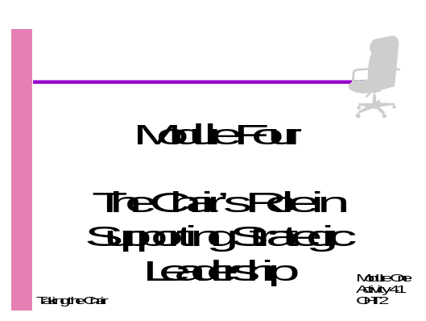

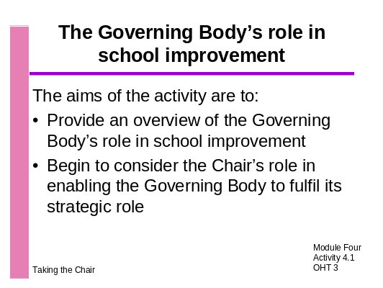
Use Activity 4.1: OHT 3 to introduce the activity

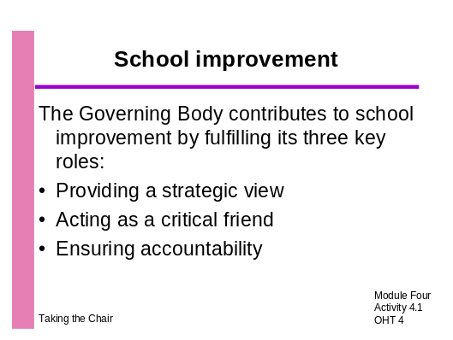
Use Activity 4.1: OHT 4 to remind the participants of the three key roles of the Governing Body

Facilitator introduction (5 minutes)

- Give out Activity 4.1: Handout 1 and Activity 4.1: Handout 2

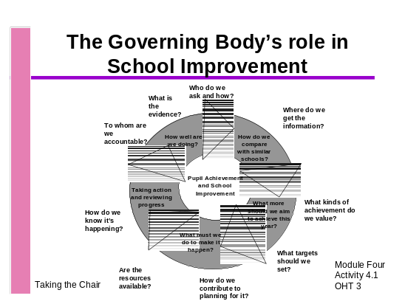
Use Activity 4.1: OHT 5 to talk about the school improvement cycle, drawing attention to the questions inside the circle and those around the outside, which are the questions the Governing Body asks

- Give participants a few moments to look at the school improvement cycle diagram
- Ask the question “What kinds of achievement do we value?”
- Put their ideas on a flip chart
- Ask the question “What is the evidence?” In other words, what kind of evidence does the Governing Body expect to see that tells them how well the school is doing?
- Put their ideas on another flip chart. This is good preparation for Activity 4.7

Discussion and flip charting (15 minutes)

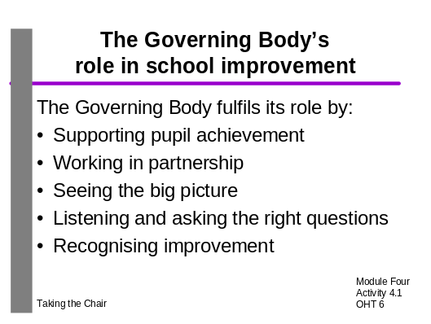Use Activity 4.1: OHT 6 to summarise how the Governing Body works to fulfil its role

Facilitator input (5 minutes)

- You could extend this activity by asking participants to look at the Governing Body’s role in school improvement on Activity 4.1: Handout 2 and considering the extent to which their Governing Body is currently effectively involved in these activities.
- Alternatively this could be taken away for discussion with other governors

The Governing Body’s Role In The School Improvement Cycle
What are our values? What is our vision?
What are we trying to achieve?
What is the evidence?
Who do we ask and how?
Where do we get the information?
What kinds of achievement do we value?
How do we contribute to planning for it?
How do we know it’s happening?
To whom are we accountable?
How do we compare with similar schools?
What more should we aim to achieve this year?
What must we do to make it happen?
Taking action
and reviewing progress
How well are we doing?
Pupil Achievement and School Improvement
Are the resources available?
What targets should we set?

The Governing Body’s Role in School Improvement

The Chair ensures that the Governing Body is appropriately involved at all stages in the school improvement cycle in:

- Developing and sharing the values and vision

- Taking the views of stakeholders into account

- Evaluating evidence on how well the school is doing

- Seeking information from a variety of sources

- Agreeing targets for improvement

- Planning to achieve improvement

- Ensuring that deployment of staffing and resources match the school’s priorities

- Reviewing progress and evaluating outcomes

- Demonstrating accountability to stakeholders for their decisions

Activity 4.2: Developing shared values

Aims

- To distinguish between values and vision
- To clarify the importance of values and vision being shared by all stakeholders
- To try out a ‘tool’ for developing shared values
- To encourage reflection on the impact of values and vision on policy and practice in participants’ schools

Overall length

- 35 minutes

Resources

- Activity 4.2: OHTs 1-5
- Activity 4.2: Handout 1
- Post-its (large)
- Flipchart and pens
- Blu-Tack

Key notes for Facilitators

- Often prospectuses confuse values, vision and aims
- Values are the core beliefs that underpin the way people think and act.
- We should not assume that they will be shared by all stakeholders in a school
- It’s important to identify those that everyone can subscribe to
- Vision is the preferred future for the school. It should be exciting and dynamic and must relate to the context in which the school is operating.
- Ofsted is clear that governing bodies should influence the values, vision and direction of the school and that the values of the community should be understood and respected by the Governing Body
- The Headteacher ’s perspective is crucial and if there is consensus amongst all key stakeholders then everyone’s efforts will be focused on the same goals
- Prepare for this activity by putting three blank flip chart sheets up around the room

Task 1: Defining values and vision

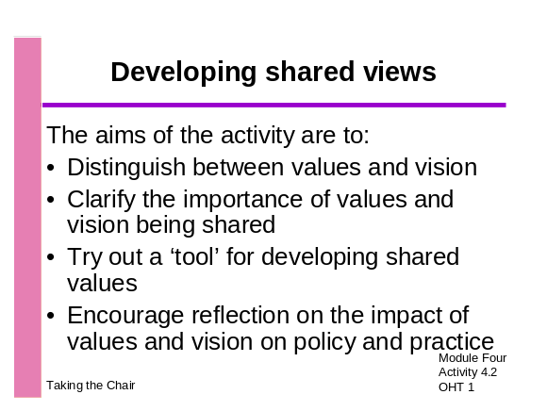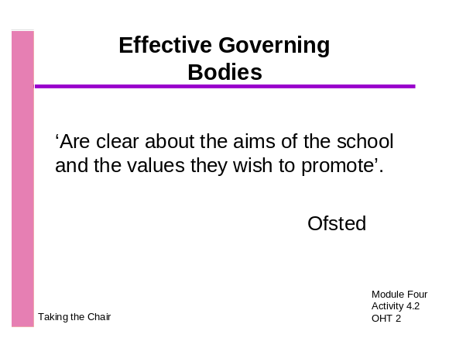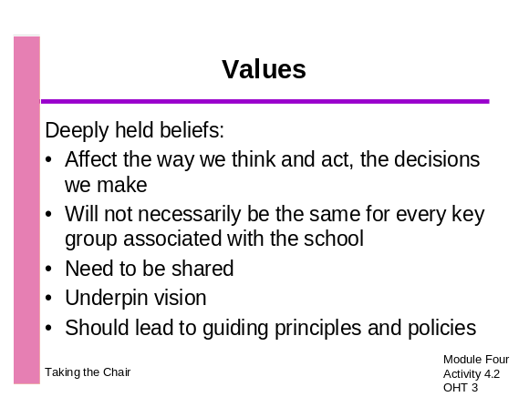Use Activity 4.2: OHT 1 to introduce the aims of the activity and include the points raised above

Use Activity 4.2: OHT 2 to make a point about the importance of the Governing Body having a clear view of the values they wish to promote

Use Activity 4.2: OHT 3 to talk through the meaning of ‘values’.

- Ask participants whether they think it is important for staff, pupils and parents to share values and whether they have examples of what can happen if values are not shared

- You may want to let participants know that shared vision is the topic of a later activity (4.4)

Facilitator input and discussion (10 minutes)

Task 2: Developing shared values
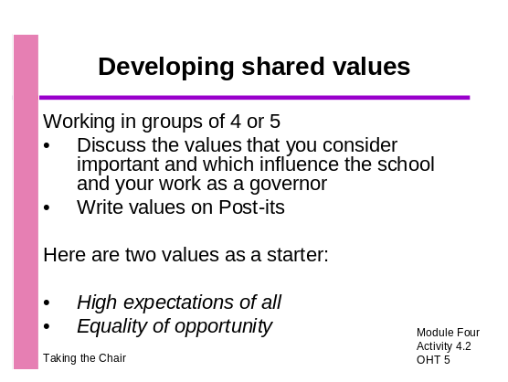
Use Activity 4.2: OHT 5 to introduce the task

- Ask participants to work in groups of 4 or 5
- Give out Post-its and felt pens and ask groups to discuss values – what values influence their work as governors?
- Participants should write one value on each Post-it

- Once participants have had time to consider their own values, ask them how others might answer – staff, parents and children. Maybe ask a separate question about what values do they see in evidence in the way the their school is led and managed. Are they the same as their personal values?

- Move around the groups and encourage participants to be clear about the values they decide on by asking what they will look like in practice

Introduction and group work (15 minutes)

- Towards the end of the time allowed for group work, start collecting up the Post-its and put them on the flip charts, grouping like values together. You will find that themes emerge. Stop the activity and ask participants to put up any remaining Post-its, grouping them with like values
- Ask participants to stand in front of the flip charts and identify the common themes
- Look at the theme or value with the most Post-its and ask how the particular value influences the work of the school and relationships
- Ask whether the participants feel that any important values have been omitted – use Activity 4.2: Handout 1 to suggest ideas if necessary, or give out to take away for further reflection in school
- Ask participants if and how shared values have been developed in their schools and how they influence policies

Plenary discussion (10 minutes)

Developing shared values

One school has defined its values in this way:

Our school is developing a learning community where:

- Everyone is proud to belong
- We all have high expectations of ourselves and each other
- Individuals respect each other
- There are positive attitudes to learning
- Many different styles and ways of learning are valued
- It is recognised that we all go on learning throughout our lives
- Everyone respects the right of others to learn
- We recognise the importance of playing a part in our wider community

Values prompts

- High expectations of all  - Independent learners  - Imagination  - Challenge  - Enjoyment  - Positive reinforcement  - Pride in achievement  - Added value  - Participation  - Equality of opportunity  - Fair treatment for all  - Empowerment at every level  - Lifelong learning  - Celebrating ethnic and cultural diversity  - Consistency  - Financial enterprise  - Value for money | - Mutual respect  - Integrity  - Truth  - Justice  - Compassion  - Responsibility  - Accountability  - Openness  - Honesty  - Self-esteem  - Self control  - Leadership at all levels  - Team working  - Partnership with parents  - Community involvement  - Security (physical/emotional)

Activity 4.3: Looking for evidence of values in action

Aims

- To highlight the importance of governors having evidence that values are translated into the action
- To explore what evidence of applied values governors can look for in the school’s culture and ethos

Overall length

- 30 minutes

Materials required

- Activity 4.3: OHTs 1 and 2
- Activity 4.3: Handouts 1 and 2
- Activity 4.3: Crib sheet
- Flip chart and pens
- Blu-Tack

Key notes for Facilitators

- If the previous activity has been used, participants will have explored a set of values
- This activity asks participants to consider the actual evidence they might see around the school if the agreed values were being lived out in practice.
- If you have not used the previous activity, a short discussion about the types of value statements found in the school’s prospectus would provide the starting point – you may have asked participants to bring the school prospectus as part of the preparation for the session
- During an inspection, governors will be asked how they know that some of the statements made about the school are true. By encouraging the Governing Body to try out this exercise for themselves, the Chair can develop their ability to provide challenge and support as the critical friend
- The evidence might be tangible but will also be found in observing relationships and how people behave towards each other
- If you have time to extend this activity, participants might also be encouraged to think about what evidence of values in practice they would like to see in 5 years time – this would encourage some futures thinking about changes to the nature of learning and teaching
- A crib sheet has been included for the Facilitator giving a broad range of possible evidence of values in action

Task 1: Looking for evidence of values in action

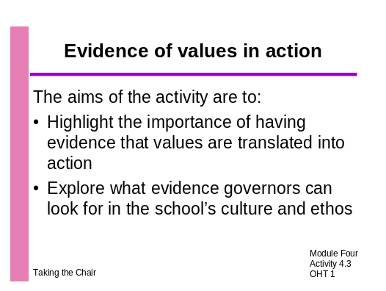Use Activity 4.3: OHT 1 to introduce the aims of the activity

- Remind participants of the importance of not relying on others for evidence of how well the school is doing.
- By identifying first hand evidence that values are translated into action, the Governing Body will gain confidence in accounting for the school to stakeholders such as parents and Ofsted

- Divide participants into groups of 3 or 4
- Give out the task sheet, Activity 4.3: Handout 1, and the values and evidence grid, Activity 4.3: Handout 2
- Give out flip chart paper and pens
- Suggest that participants only work on two or three of the values – allocate these to groups so that all are covered
- Talk through the task and make sure that everyone understands it
- Tell the participants how much time they have for the activity

Introduction and task setting (5 minutes)

- While groups are working, circulate and offer ideas for evidence, using Activity 4.3: Crib sheet

Group work (10 minutes)

- Ask groups in turn to talk very briefly about the evidence on their flip charts (1 minute)
- Invite others to add their ideas

Feedback and discussion (10 minutes)

- To complete the activity explore the following questions:
  - Would it be useful to use this activity with their own Governing Body – why and how?
  - Would the evidence they might hope to see in 5 years time be different?

Plenary discussion (5 minutes)

Looking for evidence of values in action: TASK

In groups of 3 or 4:

- Look at two or three of the values listed on the Handout

- For each value consider how you would know that the value was informing the life and work of the school

- List:

  - The evidence you might see and

  - The evidence you might hear

- Put your evidence on a flip chart and be ready to share your ideas with the whole group

Looking for evidence of values in action

What evidence would you expect to see and hear that the values on the left are being lived out in practice in the school? One example of evidence has been provided for you.

Values | Evidence to look for
There are high expectations of all | - School vision and aims displayed
Mutual respect is evident in the way that staff and pupils relate to each other: | - Pupils work without disturbing others
The school promotes positive attitudes to ethnic and cultural diversity: | - The school uses the expertise, skills and knowledge of people from ethnic minority communities
Pupils have rights as well as responsibilities: | - School council information is displayed
Pupils’ achievements are celebrated | - The work of pupils of all abilities is on display
The school environment is looked after by all | - Litter free, clean, tidy corridors, reception area, classrooms, toilets
Teaching and learning are enjoyable for adults and pupils | - Laughter, enthusiasm, energy, active participation are evident in learning situations
The school environment is a ‘safe’ place – emotional and physical security are prioritised | - Rules displayed and being followed
The role of parents as partners in the learning process is recognised and valued | - When parents visit by appointment they are seen promptly

Evidence of values in action: example evidence

Values | Evidence
There are high expectations of all | - School vision and aims displayed  - School targets displayed  - Staff follow up students who are not adhering to the school’s standards – uniform, behaviour etc  - Staff handbook describes standards for performance, behaviour etc.  - School rules are in evidence  - ‘We can do…’  - The Governing Body has agreed a code of practice to underpin its work
Mutual respect is evident in the way that staff and pupils relate to each other | - Pupils work without disturbing others  - Pupils are encouraged to work co-operatively on group tasks  - Pupils do not interrupt each other or staff  - Staff do not interrupt each other or pupils  - Pupils do not intimidate or belittle each other  - Teachers maintain control without the use of threats, humiliation etc  - The behaviour policy emphasises ‘catch them being good’  - Teachers are courteous when they speak to pupils and the reverse is true  - All staff have access to appropriate accommodation and facilities – staff rooms, work rooms, offices etc  - ‘What do you think?’  - Governors make every effort to understand and complement the professional role of the Headteacher and staff
The school promotes positive attitudes to ethnic and cultural diversity | - Staff and pupils are aware of The Race Equality policy  - The school uses the expertise, skills and knowledge of people from ethnic minority communities  - Pupils are encouraged to recognise and respect social, ethnic and cultural differences and similarities  - Signs and home-school communications are in languages befitting the pupil population  - Positive images of people from various ethnic groups and their cultural backgrounds are displayed in the school  - Celebrations of festivals of different cultures and religious beliefs  - School diary/calendar shows full range of ethnic religious festivals  - Ethnic and cultural diversity in the staff and the Governing Body are commonplace  - Special dietary needs are catered for  - Curriculum content and resources reflect ethnic and cultural diversity
Pupils have rights as well as responsibilities | - Pupils are associate members of Governing Body Committees  - Pupils are exercising leadership skills  - School council information is displayed  - Pupils are acting as mentors/buddies/counsellors for their peers  - The Headteacher and staff refer to pupils by name  - Routine management does not interrupt teaching and learning  - Visible ‘charter’ of pupils’ rights  - Pupils are aware of, and articulate about, their rights and responsibilities  - High quality teaching and resources support learning  - Home school contracts list the rights of each partner (as well as responsibilities)  - Pupils help to determine the rules and sanctions  - Suggestion box  - Exit surveys  - Staff interactions with pupils model the values of the school
Pupils’ achievements are celebrated | - The work of pupils of all abilities is on display  - Displays are up to date and in good condition  - Press cuttings books in reception area  - Displays, photos cover a range of achievements – academic, social, cultural, sporting, both in and out of school  - Display in entrance area shows destinations of most recent cohort of leavers  - Positive and public appreciation of effort as well as success – awards, assemblies, badges, stickers, certificates etc  - Staff and governors show pride in pupils’ work  - Pupils show pride in each other’s work  - Prefects chosen for their personal qualities regardless of their academic achievements  - Regular home-school communication about pupils’ efforts and successes  - Behaviour credit cards
The school environment is looked after by all | - Pupils and staff show respect for people, living things, property and the environment  - Litter free, clean, tidy corridors, reception area, classrooms, toilets  - Tidy classroom award  - Interactive wall displays are used, not damaged  - Displays are up to date  - Equipment all in good working order
Teaching and learning are enjoyable for adults and pupils | - Laughter, enthusiasm, energy, active participation are evident in learning situations  - A variety of teaching styles are employed to maintain pupils’ interest  - Pupils are encouraged to explore, to enquire and to become confident, independent learners  - Low rates of absenteeism – pupils and staff  - Some staff turnover due to promotion  - Pupils keen to display and talk about their work  - High involvement in extra curricular activities  - Nobody is left out  - School is over subscribed  - Governors welcome the opportunity to develop their skills and increase their knowledge and understanding  - Governors evaluate training before making recommendations to colleagues
The school environment is a ‘safe’ place – emotional and physical security are prioritised | - Rules displayed and being followed  - Physical security is effective but not oppressive  - All visitors wear badges  - There are no voices raised in anger  - Pupils and staff move around the site in an orderly manner  - Pupils are given opportunities to understand human feelings and emotions and the way they impact on people  - Anti-bullying policy well publicised to staff, pupils and parents.  - Named person to go to  - Buddying scheme and pupil counsellors  - Pupils feel safe offering their opinions  - Rules are applied fairly and consistently  - Everyone is ‘Health and Safety’ conscious  - The Governing Body plays an effective part in monitoring and evaluating policies on behaviour, anti-bullying, health and safety
The role of parents as partners in the learning process is recognised and valued | - Signposting around the school is effective  - When parents visit by appointment they are seen promptly  - Home school agreements are treated seriously by all partners  - Parents’ newsletters and notice boards are informative and well set out.  - The views of parents on the school’s performance are actively sought.  - Parents assist in classes  - Parent workshops and training e.g. ICT  - Parent assemblies  - The Governing Body’s annual report to parents is interesting and informative

Activity 4.4: Sharing the vision

Aims

- To consider the purpose of a vision for a school
- To consider the Chair’s role in ensuring that the vision for the school is developed and shared with the Governing Body
- To consider the way in which a shared vision underpins the Governing Body’s strategic role

Overall length

- 20 minutes

Resources

- Activity 4.4: OHTs 1 and 2
- Participants’ own school prospectus

Key notes for Facilitators

- If you have asked participants to bring their school prospectus containing the school’s values and vision, these can be used to inform the discussion
- The purpose of the discussion is to challenge participants to consider:
  - The importance of vision
  - Why it is important to have a shared vision
  - How a vision should influence the decisions of the Governing Body
  - What the Chair can do to ensure that the Governing Body is involved in developing a shared vision
- Some participants may consider the idea of ‘vision’ to be rather woolly. However, the development of a clear vision for a school is a key learning point for candidates on the National Professional Qualification for Headship and one that makes them feel very secure in their ability to lead a school forward with a sense of purpose
- Without a vision to guide the future of the school and what it wants for its pupils, decisions are made in a vacuum. All plans should be evaluated for the contribution they will make to the school’s preferred future
- If the Governing Body and the Headteacher and staff do not share a vision, they may have different priorities and pull in different directions
- Vision is what inspires people to keep working towards their goals even in times of difficulty
- It is often the Headteacher who will generate the vision for the future.
- Some Headteachers will develop a vision statement in partnership with the Governing Body, the staff and other stakeholders. In some schools the involvement of others may be an exercise without a great deal of meaning – in which case the Chair will need to consider how to encourage greater involvement for the Governing Body
- The vision belongs to the whole school, not to an individual or one group within the school

Task 1: Sharing the vision
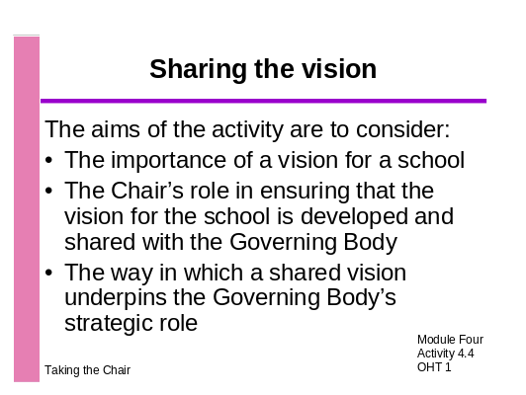
Use Activity 4.4: OHT 1 to talk about the aims of the activity

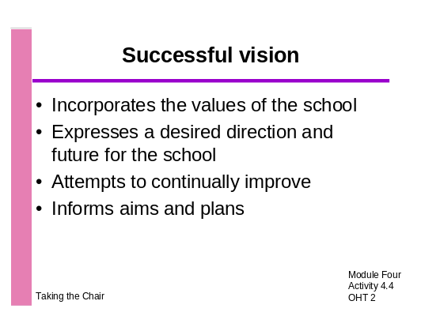
Use Activity 4.4: OHT 2 to discuss a definition of vision

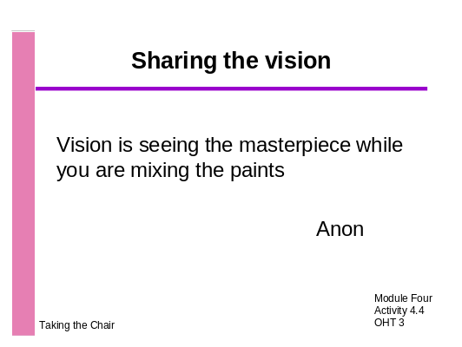
Using Activity 4.4: OHT 3, hold a short discussion about what the quotation means in the context of a vision for a school, making some of the key points from the notes above if these do not emerge from the discussion

- A key point to make here is the connection between having a vision and showing strategic leadership

Facilitator input and discussion (10 minutes)

- Ask how the vision for their school has been developed, what part they have played in it and what Chairs can do to ensure that the vision is shared

Plenary discussion (10 minutes)

Activity 4.5: Evaluating strategic effectiveness

Aims

- To develop awareness of what is meant by “strategic”
- To explore what it means to act strategically
- To evaluate the strategic effectiveness of the Governing Body
- To reflect on the Chair’s role in ensuring the Governing Body fulfils its strategic role

Overall length

- 35 minutes

Resources

- Activity 4.5: OHTs 1 and 2
- Activity 4.5: Handouts 1 and 2

Key notes for Facilitators

- This activity is aimed at reinforcing an understanding of the strategic role
- Definitions of ‘strategic’ include: ‘Having a plan or technique for achieving an end’, ‘Identifying the way forward in a complex environment, referring constantly to a longer term vision for the organisation’
- The objective is to stand back and consider what it means to act strategically and what the Governing Body does that contributes to a strategic view
- The questionnaire that will be completed during the activity could be taken away and used for further discussion with the Headteacher and the Governing Body
- Emphasise the practical application of this activity:
a) In ensuring that evidence of the work of the Governing Body is well understood and documented in preparation for Ofsted and
b) As part of the Governing Body’s contribution to school self-evaluation

Task 1: Evaluating strategic effectiveness
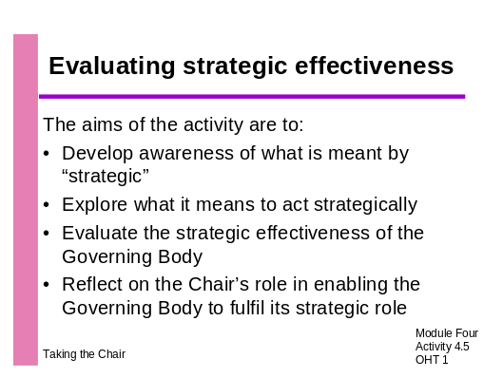
Use Activity 4.5: OHT 1 to introduce the aims of the activity

- 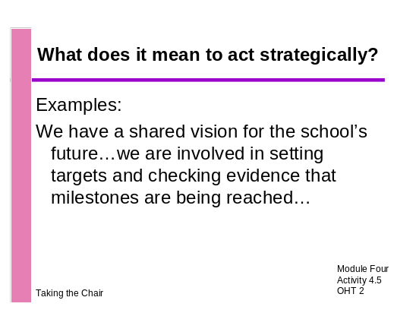Brainstorm examples of what it means to act strategically, using Activity 4.5: OHT 2 to start the discussion

- Put the ideas on a flip chart, encouraging contributions from all and valuing all contributions`

- Give out Activity 4.5: Handout 1
- Ask participants whether any strategic responsibilities have been left off the brainstormed list. Add any further examples suggested

Facilitator introduction and brainstorm (10 minutes)

- Give out Activity 4.5: Handout 2. Explain that the questionnaire gives more detailed examples of what the Governing Body does in its strategic role
- Draw attention to the scoring
- Ask participants to work on their own and quickly score their Governing Body’s effectiveness in each area of activity
- Ask them to note, if possible, one piece of evidence to justify the score for each area

Individual work (5 minutes)

- Ask participants to work in fours (moving people around the room to work with different colleagues if they have been with the same group for a while)
- Ask participants to refer to their evidence and discuss:
  - What contributes to excellence in areas scored 1
  - What could a Chair do to assist the Governing Body in improving areas scored 4 – the third column of the handout could be used to note down any ideas generated
- You may need to give some guidance on the number of areas to be discussed in the time available

Group work (10 minutes)

- Hold a plenary discussion
- Ask for one or two examples from the group of strategic activities scored 3 or 4 and what they think the Chair could do to improve strategic effectiveness
- Complete the activity by suggesting that participants might like to finish completing the final box (noting how they could encourage the Governing Body to take further action) in consultation with others (the Headteacher or the Vice-Chair, for example)

Plenary discussion (10 minutes)

The strategic role of the Governing Body

- The Governing Body has a statutory responsibility to ‘conduct the school with a view to promoting high standards of educational achievement’: Education Act 2002

- The Governing Body decides what it wants the school to achieve and sets the framework for getting there

- The Governing Body agrees vision, values, plans, policies and targets and reviews progress

- The head is responsible for internal organisation, management and control of the school and advises on and implements the Governing Body’s strategic framework

From: Roles of Governing Bodies and Headteachers

The Chair leads the Governing Body in:

- Focusing its work on raising standards of achievement, establishing high expectations and promoting effective teaching and learning, so that pupils achieve their potential

- Ensuring that all those who have an interest in the success of the school contribute when the values and aims are being agreed

- Deciding what they want the school to achieve, agreeing priorities for the improvement plan and ensuring resources are used wisely

- Helping to set and keep under review the policies that provide a broad framework within which the Headteacher and staff should run the school

- Ensuring systems are in place to gather evidence of progress

Evaluating the strategic effectiveness of the Governing Body

Acting Strategically |  | Score: 1 = excellent, 2 = good,  3 = satisfactory, 4 = priority for improvement
Areas of strategic activity | Score | Evidence we can produce  Actions we need to take
1. Our work is clearly focused on school improvement.
2. We have a shared vision for the school’s future.
3. We regularly review the aims and objectives that will help us achieve our vision.
4. We know our school’s strengths and weaknesses
5. We are actively involved in setting the priorities of the school improvement plan.
6. We check that the school’s budget supports the improvement plan.

7. We are confident that the school is effectively led and managed.
8. We ensure that we have a staffing structure and personnel policies that create the professional team to meet our school’s needs.

9. We ensure that our performance management process supports the improvement plan.
10. We are involved in setting targets and checking evidence that milestones are being reached.
11. We ensure that policies are reviewed regularly to ensure that they are current and are effective in supporting the school’s aims and values.
12. We have a programme in place for evaluating the impact of our strategic decisions.
13. We have a strategic view of how our Governing Body will develop.

Complete the third column in consultation with the Governing Body and the Headteacher

Activity 4.6: Getting involved in school improvement planning

Aims

- To explore the Chair’s role in ensuring that the Governing Body is involved in the strategic leadership of the school
- To examine ways in which the Chair ensures involvement of the Governing Body in the development of the school improvement plan

Overall length

- 30 minutes

Resources

- Activity 4.6: OHT 1
- Activity 4.6: Handout 1

Key notes for Facilitators

- This activity challenges participants to reflect on their current involvement in school improvement planning and what they can do to improve the involvement of the Governing Body in using evidence
- In order to share leadership and fulfil their strategic role, the Governing Body should be involved throughout the planning cycle so that they have evidence of what the school does well and what it needs to improve, and can challenge the school to ensure that the plan is a vehicle for improvement
- Many schools will have well developed strategies for involving staff, governors, parents and pupils in setting the strategic direction of the school and contributing to the annual updating of the school improvement plan
- Many schools will take a systematic approach to the use of evidence to support the identification of improvement priorities leading to the production of detailed plans
- There will be others where plans lack detail, are mainly the work of the Headteacher and where the Governing Body’s role is reduced to rubber stamping the plan
- Participants consider what factors need to be taken into account when deciding on priorities. These include:
  - The LEA’s view of the school’s priorities
  - The targets agreed with the LEA
  - The LEA’s Education Development Plan
  - National initiatives (see Appendix 6 (The National Agenda) in the Toolkit Introduction)
  - Local initiatives
- The participants may well have very different experiences of contributing to school improvement planning. Where participants have brought with them their school improvement plans, ask if they could be shared among the groups for this activity
- The scenarios illustrate how two schools have approached a shared approach to school improvement planning and act as a springboard for participants’ reflection on their Governing Body’s involvement and how it might be developed. These scenarios are included for illustration only and you may have more appropriate examples for your group to consider
- There will probably be some interesting discussions about the importance of Governing Body involvement in school improvement planning versus the demands on the time of volunteers
- The value of this activity is in sharing effective and efficient strategies that enable a high level of Governing Body involvement

Task 1: Getting involved in school improvement planning

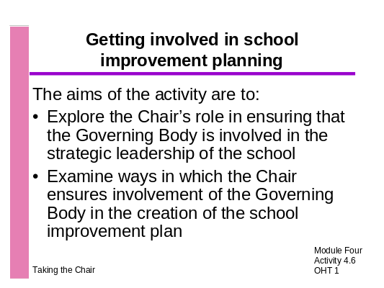Use Activity 4.6: OHT 1 to talk through the aims of the activity

- Give out Activity 4.6: Handout 1 and allow time for reading

Introduction and reading (10minutes)

- Ask participants to form groups of 4 and to discuss
  - When and how the Governing Body is involved in improvement planning
  - How effective that involvement is
  - 2 ‘good practice’ tips to share with the others

Group discussion (10 minutes)

- Take feedback from the groups on ‘good practice’ tips adding any local guidance
- Refer back to the school improvement cycle diagram for comments on when some of these activities might take place

Plenary discussion (10 minutes)

Getting involved in school improvement planning

The two examples set out below show how the Governing Body might share strategic leadership with the Headteacher and others in the school. Some schools set aside a day for staff and governors to work together on evaluating the current position of the school and setting priorities for development.

High Hopes Primary School

On the first non-pupil day of every year the staff and governors at High Hopes Primary School come together for a day to celebrate the achievements of the previous year and plan for the year ahead.

They begin by reviewing their statement of values, vision and aims, to ensure it remains relevant and is shared by everyone. Working in mixed groups, they then evaluate the school’s strengths and weaknesses over the past three terms. A variety of documents are monitored such as the school improvement plan, the PANDA and the LEA review – a self-evaluation exercise carried out each year by the Headteacher, Chair and LEA Development Adviser.

Each group feeds back the outcomes of its discussion and points are recorded on a flip chart. The whole group then decides which should be the priorities for the forthcoming year, and the improvement plan is revised accordingly.

This process means that all the governors start the year with a clear understanding of the direction the school is taking. The Governing Body then plans its programme of work for the year focusing on the key priorities that have been decided.

Workwell Secondary School

Workwell Secondary School involves all its staff and governors in the planning process throughout the year. In January the Senior Leadership Team, middle managers and the Governing Body meet together. The aim of the session is to review the current plan and to formulate priorities for the coming year. The working groups for the discussions are based on the Governing Body’s four committees: Personnel, Finance, Curriculum and Premises.

The Headteacher sets the scene and highlights any new developments that need to be taken into account such as national changes to the curriculum. The groups then review and evaluate the current plan. This involves identifying where the success criteria have been met and why, and where they have not and why. The key points are fed back to the whole group.

Following this the whole group identifies broad priorities. For example the implications of the changes to the 14-19 curriculum were identified for each group to look at. Each group would be expected to consider these implications with a whole school view and a focused view linked to their governor committee remit e.g. the Personnel group would need to identify the staffing and development needs and present these back to the whole group.

The session ends with key priorities being agreed. An agreed set of actions is then identified to enable the plan to be written.

A common format for the plan is available electronically for all staff and governors. Each governor committee, all subject departments and the senior leadership team write their part of the school improvement plan. This includes an evaluation of the current plan, an overview of the coming year and a detailed action plan for the coming year. These are collated into the final plan. All detailed plans include costings, which are then linked with the budget and approved by the finance committee. The plan is finalised and approved by the full Governing Body.

Everyone uses the plan throughout the year to guide action and monitoring. In the summer term the governors and staff meet again to work together on the key priorities. For example a key priority was how the school assesses pupil progress. A keynote speaker is invited followed by mixed staff/governor workshops.

Activity 4.7: Sources of information

Aims

- To ensure that participants are aware of the range of sources of information available to assist the Governing Body in understanding the school’s strengths and weaknesses
- To underline the importance of information and data on quality and standards in order to carry out the strategic role
- To prompt participants to consider the action they might take if they do not have access to an appropriate range of information

Overall length

- 30 minutes

Resources

- Activity 4.7: OHTs 1 and 2
- Activity 4.7: Handouts 1 and 2
- Activity 4.1: Handout 1
- Flip chart and pens
- Blu-Tack

Key notes for Facilitators

- Task 1 is a quick activity to encourage further thinking
- The Chair may be the gateway to information for the Governing Body
- To ask critical friend questions and make sound strategic decisions, the Governing Body needs to have access to all available information about the school in an understandable form
- Governing Bodies should seek and obtain firm evidence of improvement for the purposes of their accountability during an Ofsted inspection and for self-review
- The Chair needs to work with the Clerk and the Headteacher to ensure that the Governing Body has access to the information it needs
- As access to information and the quality of information varies from school to school, not all participants will be aware of what they can expect in the way of information from a range of sources
- Activity 4.7: Handout 1 lists possible sources and types of information. You might want to expand the sources of information available from your LEA
- When the information is required and what the Chair can do to ensure that good use is made of it is dealt with in another activity
- Prepare for this activity by putting up 4 or 5 flip chart sheets around the room where volunteers from the group can write on them

Task 1: Sources of information

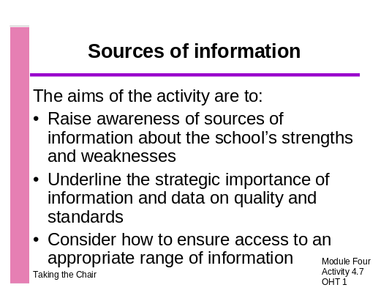Use Activity 4.7: OHT 1 to introduce the aims of the activity, underlining the Chair’s role in ensuring that the Governing Body gets the information it needs – in the right form and at the right time

- Refer participants to the school improvement cycle diagram (Activity 4.1: Handout 1) and remind them that the strategic role requires the Governing Body to be able to answer the questions “How well are we doing?” and “How do we compare with other schools?”

- Ask where information on standards and quality might come from…e.g. from the Headteacher, staff etc. As they describe the sources, head up separate flip charts pinned round the room. Examples of sources are listed on Activity 4.7: Handout 1 – you will probably want to group some on one flip chart. It is probably better to get people to think about the sources rather than have the flip charts headed up in advance
- Ask for two or three volunteers to stand ready with flip chart pens
- You and/or the volunteers write up the types of information under the appropriate source as they are suggested

Introduction and brainstorm (10 minutes)

- Give out Activity 4.7: Handout 1 and identify any missing items which might have been included on the flip charts
- Have a short discussion on whether most of those present have access to all this information. If they don’t, ask for ideas about how they might remedy this situation.

Facilitator led discussion (10 minutes)

Task 2: Reliability of evidence
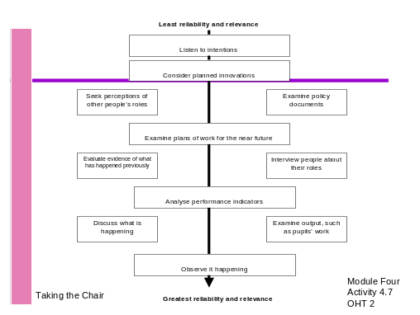
Give out Activity 4.7: Handout 2 or show the diagram using Activity 4.7: OHT 2

- Explain that this is taken from the Ofsted Inspection Handbook and helps inspectors to consider the reliability of evidence
- It is important for the Governing Body to consider how reliable is the information it has about standards and quality and not to rely on one source
- The diagram shows that information received verbally about future intentions is the least reliable type of evidence and that observing something happening is the most reliable. In between are various strategies that can be used to test the reliability of information
- Take one or two examples of information and ask participants to rate their reliability as evidence
Facilitator led discussion (10 minutes)

Sources of information

From the school:
- School mission statement/statement of values and aims
- School improvement/development plan, including targets
- Post-inspection action plan
- Headteacher’s report to the Governing Body
- Other reports and presentations by staff to governors
- School prospectus
- Staffing structure
- Curriculum plans
- Reports of staff professional development and INSET days
- School policy documents
- Conversations with staff and pupils
- School council meetings
- Examples of pupils’ work
- Baseline assessment, teacher assessments, value added data
- Outcomes of school self-evaluation
From the Governing Body:
- Reports of governors’ visits to school
From the community:
- Parents’ pre-Ofsted questionnaire results
- Views of parents, other schools, neighbours and local businesses
- Local and national media
From the LEA:
- LEA curriculum guidance
- Benchmarking/Value Added data
- LEA School Improvement Adviser’s Notes of Visit
From the DfES:
- SATs and public examination results, league tables
- Financial benchmarking data
From Ofsted:
- Ofsted reports
- HMI monitoring reports
- PANDA and Autumn Package

Sources of evidence
Adapted from Ofsted Handbook for Inspection

Listen to intentions

Consider planned innovations
Examine policy documents
Seek perceptions of other people’s roles

Examine plans of work for the near future
Evaluate evidence of what has happened previously
Interview people about their roles

Observe it happening
Discuss what is happening
Examine output, such as pupils’ work

Analyse performance indicators
Least reliability and relevance
Greatest reliability and relevance

Activity 4.8: Using information strategically

Aims

- To highlight the Chair’s role in managing access to information
- To consider when certain types of information should be available
- To explore the Chair’s role in ensuring the Governing Body makes good use of information at appropriate times in the school improvement and planning cycle

Overall length

- 40 minutes

Resources

- Activity 4.8: OHTs 1 and 2
- Activity 4.8: Handout 1
- Activity 4.1: Handout 1
- Guidance on the content of Headteachers’ reports from www.governornet.co.uk

Key notes for Facilitators

- In order to carry out its strategic role, the Governing Body needs to be able to answer the questions “How well are we doing?” “How do we compare with similar schools?” and “What more should we aim to achieve this year?”
- The Governing Body needs to consider the evidence of school performance and standards from a variety of sources
- Stress the need to examine sources of information with a critical eye in order to ask the right questions
- The Governing Body needs to challenge the school as its critical friend and ensure that the improvement priorities are the ones that will make a difference to pupil achievement
- The Chair has a role to play, when constructing the agenda for meetings, in ensuring that information is received and dealt with in line with the school improvement cycle
- This activity encourages participants to think about:
  - When the information should be made available
  - What use needs to be made of it
  - How the Chair ensures that it comes to the attention of the Governing Body
  - Whether responsibility for using and evaluating the information can or should be delegated
- The length of the activity can be adjusted according to the number of types of information you ask each group to look at. The minimum recommended number is two pieces of information
- You will need to adapt the background information given in the light of practice in your LEA – in particular identify the latest guidance on who has access to the school improvement adviser’s monitoring report on the school

Task 1: Using information strategically
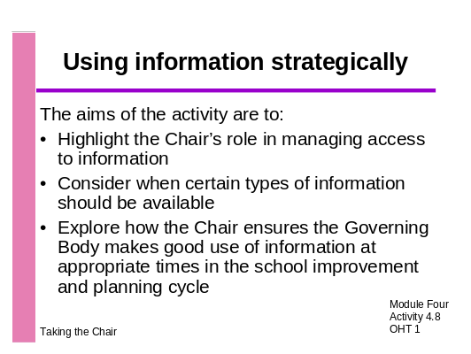
Use Activity 4.8: OHT 1 to introduce the activity and make the key points given above – you may also want to refer participants back to the school improvement cycle diagram on Activity 4.1: Handout 1

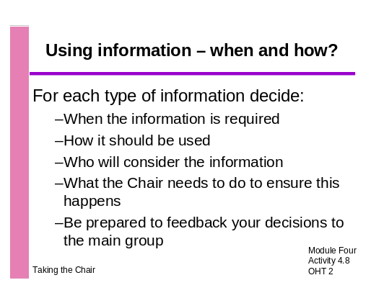
Use Activity 4.8: OHT 2 to explain the task

- Divide the group into 4’s and give each group 4 types of information
- Tell the groups how much time they have for the activity
- Ask them to ensure that they think about the information needed for the last box on each sheet (What does the Chair do to ensure this happens?)

Group work (15 minutes)

- Take each item of information in turn and ask groups who have worked on it to report back to the others on the task
- Ensure that they have thought about their role in managing how and when the information will be used
- Ensure that each group has a turn to go first
- Take the opportunity to point out good practice and give advice where necessary – if it is not forthcoming from participants
- Suggest that the grids could usefully be discussed with the Headteacher

Feedback on task (25 minutes)

Using Information Strategically

Source of information | Background
PANDA: Performance and Assessment Report | Published Autumn/Spring. Benchmarks school’s performance in end of key stage tests against all schools nationally and similar schools. Contains value added data – measuring pupils’ attainment against their own starting points. Can be downloaded from internet using code supplied to school.
When is this information required? | How should it be used?
Who will consider the information? | What does the Chair do to ensure this happens?

Source of information | Background
Headteacher’s Report | Likely to include information on: impact and progress of the School Improvement Plan/Ofsted Action Plan, pupil progress, policy review, staffing, relationships with parents and others, management issues Headteacher has dealt with, school budget, extra-curricular activities and achievements of pupils.
When is this information required? | How should it be used?
Who will consider the information? | What does the Chair do to ensure this happens?

Source of information | Background
Budget monitoring report | Contains information about original budget allocations, spending to date, percentage of budget spent so far and predicted over or under-spend.
When is this information required? | How should it be used?
Who will consider the information? | What does the Chair do to ensure this happens?

Source of information | Background
A proposal for a major item of expenditure in the next financial year |  | Helpful reports contain: Background to the proposal, options and their consequences, costs, comparisons, timescales, reference to relevant priorities, policies and plans. Helpful reports are summarised and backed by clear verbal explanations.
When is this information required? |  | How should it be used?
Who will consider the information? |  | What does the Chair do to ensure this happens?

Source of information | Background
Report from Head of Department or Subject Leader | Helpful reports contain: Reference to school improvement plan priorities, progress against timescales and success criteria, data on attainment, evidence of achievement, evidence of monitoring and evaluation of teaching and learning, progress of pupils with special needs.
When is this information required? | How should it be used?
Who will consider the information? | What does the Chair do to ensure this happens?

Source of information | Background
A report from the school’s LEA school improvement adviser | The frequency of LEA monitoring visits and the focus depends on how well the school is doing. There are variations across LEAs in who sees the adviser’s report. Governors should check national guidance. The adviser may agree a rating for the school based on the school’s self-evaluation and the adviser’s observations.
When is this information required? | How should it be used?
Who will consider the information? | What does the Chair do to ensure this happens?

Activity 4.9: The strategic use of resources

Aims

- To reinforce the importance of linking budget setting to school improvement planning
- To consider the importance of staff development in the light of national initiatives and how this influences budget setting
- To highlight the importance of the Chair being well informed in order to ensure the Governing Body is making strategic use of resources

Overall length

- 30 to 40 minutes

Resources

- Activity 4.9: OHT 1
- Activity 4.9: Handouts 1 and 2
- Two statements on card or paper in large letters
  - Spending on Continuing Professional Development (CPD) should be safeguarded at all costs
  - We have much higher spending priorities than sending staff and governors on courses
- Blu-Tack

Key notes for Facilitators

- There is a lot of background information to this activity (see Activity 4.9: Crib sheet 1), but the activity itself is very straightforward and you may only need to draw on it if participants themselves do not raise the issues
- Draw participants’ attention to the school improvement cycle diagram and point to the stage “What must we do to make it happen” – this activity is about strategic budget setting and the use of resources to make it happen
- National initiatives make demands on staff for change and change often needs to be supported by professional development
- In times of financial constraint governors have to juggle priorities and in some schools it is the Continuing Professional Development (CPD) budget that suffers, particularly as there is now so little ring fencing of allocations from Standards Fund.
- This activity has the potential to link three considerations together:
  - How well does the budget support the school improvement priorities?
  - What will be the impact on the implementation of change and staff motivation if funding for staff professional development is not safeguarded?
  - What are the pressures to spend on staff development arising from performance management and national initiatives?
- Participants should raise workforce remodelling as a key factor in their arguments. If participants have not attended local training on remodelling, you might want to remind them of the key messages from ‘Workforce Remodelling – a Guide for Governors’
- Governors also need to allocate resources for their own development
- There are no right answers to this activity but participants should be aware that:
  - Remodelling has many strategic implications for governors
  - There should be a commitment to train, develop and motivate all staff for the improvement of the individual school and the wider education community
  - Staff are the vital resource without whom improvement and change cannot be implemented
  - The Governing Body needs to be aware of a great many pressures to spend from within and from outside the school when deciding how the budget should be allocated
- Prepare for the activity by putting the statement cards at opposite sides or ends of the room and ensure that you have enough space for the participants to stand up and move around. (Putting the two arguments up without comment at the beginning of the session might provoke some private thinking before you get to this activity.)

Task 1: The strategic use of resources
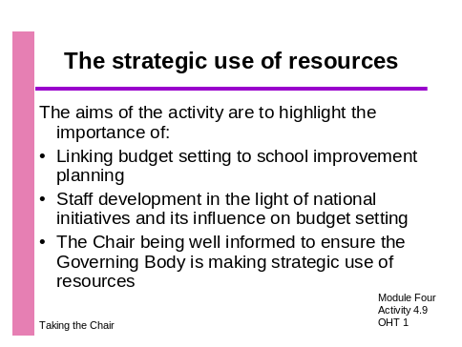
Use Activity 4.9: OHT 1 to introduce the activity without elaborating on the themes. You hope the points will come out in the discussion

- Draw participants’ attention to the two statements displayed and ask them to get up and stand on an imaginary line between the two statements to indicate their position in relation to them. (i.e. those supporting the statements strongly will stand close to them, the don’t knows will be in the middle and others will position themselves along the imaginary line according to the strength of their views)

- Start with a person in the middle and ask him/her to explain why they chose that position.

- Invite others to ask one question only of this person or make one observation.

- Take another person who is towards the centre and repeat the process.

- When you have heard from about 5 people near the centre of the continuum, pick those at the extremes and ask them to argue their case

- Let the discussion open up and broaden. Stimulate a discussion on the relative importance of safeguarding spending on professional development.

- Challenge what people are saying using the key notes raised above. A number of related questions have been included on Activity 4.9: Handout 1 which you might want to use in the discussion and for the participants to take away and share with their Headteacher and Governing Body

- Finish the discussion by asking participants to ‘vote’ again. Invite the participants to return to their seats and ask for key learning points arising from the activity and any actions that they plan to take as a result of the discussion.

- Give out Activity 4.9: Handout 2 for background information

Facilitator introduction and group activity (30-40 minutes)

The strategic use of resources for
Continuing Professional Development (CPD)

- Does the school’s performance management policy play an effective part in identifying the development needs of individual staff?

- Do we have procedures for identifying the development needs of support staff and are they fair?

- What discussions about remodelling have taken place in our school?

- Do we know how our school plans to approach the remodelling tasks?

- What happens to the information gathered? Does it translate into an effective plan to meet the CPD needs of all staff?

- What is the relationship between the CPD coordinator and the senior leadership team and the Governing Body?

- Does the Governing Body have access to the information it needs to set a strategic budget?

- How well does the Governing Body plan for its own development?

- Is an annual evaluation of the impact on pupil achievement of expenditure on professional development presented to governors so that they can judge value for money? Are we getting value for money from expenditure on CPD?

The strategic use of resources – background information

- Financial Management Competencies Framework for Governors
A Financial Management Competencies Framework for Governors will be available from March 2004. The framework has been developed by the Department for Education and Skills for use by individuals that wish to identify their personal training and development needs and to find out what financial management competencies governors have between them.

- Financial Management in Schools Website
The National College for School Leadership’s website, www.ncsl.org.uk has pages dedicated to school financial management. The site contains top tips, interactive scenarios, case studies, references and useful links to other related sites.

- Financial benchmarking
A financial benchmarking web site has been established and financial data on your school will have been supplied by your LEA.

Benchmarking your expenditure will help you to:
- Focus on planning and managing your budget;
- Identify areas for improvement;
- Set targets for improvement;
- Achieve best value - quality v. cost;
- Improve the effectiveness of your spending to improve performance;
- Deliver educational services to a defined standard.
Most importantly, benchmarking your finances can help lock your school into the cycle of continuous improvement and to develop a culture where it is easier to question the norm and to make changes. It is essential that financial benchmarking is not used solely to focus on reducing costs, but also to improve the quality and impact of your school's services. It might be difficult to measure improvements in quality through financial benchmarking but there can be significant quantifiable gains in pupil and staff satisfaction. If used in conjunction with the annual Autumn Package of Pupil Performance the impact on pupil attainment can be quantified. Schools can log onto the site using the usernames and passwords that they use for the Data Collection Website and for School2School. www.teachernet.gov.uk/management/tools/schoolfinance/

- Remodelling the School Workforce
Remodelling may well lead to a fundamental review of long-term budget deployment. For more information on the Governing Body’s role in remodelling go to http://www.remodelling.org./who_governors.php

- Value for Money
The DfES has a Value for Money website offering practical advice for ensuring that your school makes best use of its resources. http://www.dfes.gov.uk/valueformoney/

- Getting the Best from your Budget
In 2000 Ofsted and the Audit Commission published ‘Getting the Best from your Budget’. It can be downloaded from www.ofsted.gov.uk and provides guidance on the effective management of school resources. It emphasises the role of the Governing Body in making decisions, challenging decisions and monitoring and evaluating impact.

- Evaluating financial management
The Audit Commission web site for schools has on-line self-evaluation tools linked to ‘Getting the Best from your Budget’ and its sister publication, ‘Keeping Your Balance’. Any governor can use the self-evaluation tools by logging on to www.schools.audit-commission.gov.uk and clicking on ‘Access for governors’. The username required is the school’s DfES number. If no one from the Governing Body has used the site before you will be asked to set up a password. If someone has used the site before, you will not be able to use the site until you have found out the existing password.

Activity 4.10: Plenary Activity

Aims

- To reflect on learning
- To evaluate the session
- To prepare for the next session or module

Overall length

- 15 minutes

Task 1: Plenary discussion

- Introduce the plenary session using Activity 4.10: OHT 1

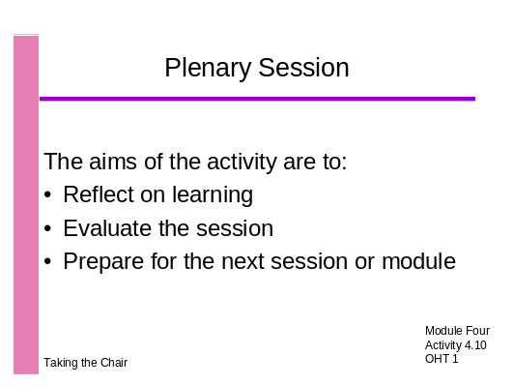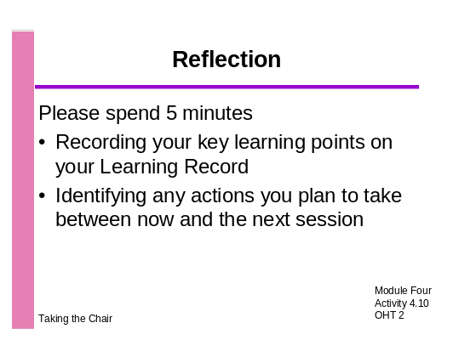
- Encourage participants to spend 5 minutes recording any actions for the future identified in this session on their Learning Record using Activity 4.10: OHT 2

- Take one point from each participant and record it on a flip chart
- Distribute any remaining related handouts
- Discuss the objectives of the next session and distribute any preparatory tasks
- Ask for any questions or comments

Plenary session (15 minutes)

Task 2: Preparation for Module Five

- Activity 5.4 (Using pupil data) requires Activity 5.4: Handouts 1 – 4 to be sent out in advance. Giving participants the opportunity to look at PANDA data before the session will shorten the time for the activity. It might also encourage participants to discuss the task with their headteacher.

- You will need to know whether participants require the primary or secondary data from Activity 5.4: Handout 2 (primary) or Activity 5.4: Handout 3 (secondary)

- When giving out the handouts, or in a covering letter if they are to be posted in advance, you might want to reassure participants with a quote from Unit Five of the Distance Learning Pack

“Governors do not need to be experts in data analysis but should ask critical friend questions. The Chair helps them to do this by being sufficiently familiar with the information available to assist the Governing Body in framing suitably challenging questions.”

